International symposium ART DIALOGUE – INTER SPACE

Galerie Klatovy/Klenová
Náměstí Míru 149
339 01 Klatovy
Czech Republic
Symposium dates:
September 18th – September 29th, 2018
Exhibition dates:
September 29th – October 31st, 2018

International Bienial for MFA graduates „Art Dialog- Interspaces“ continues in a tradition of interaction of art professors and emerging artists from selected art schools in the Gallery of Klatovy / Klenova. During the symposium the students and their professors participate in multimedia projects which are composed of installation based on videoprojections, photography, sculpture or painting aimed at artwork made out of local material. The symposium is accompanied by lectures and video projections to inform about current trends in various fields of art. The theme is specifically focused on interspace dialogue not on material processing.
The exhibition of works created by students and teachers during the symposium is held at Klenova Castle Granary and its surroundings. The Gallery also publishes an exbition catalog.
The Symposium is a creative meeting of art professors and emerging students/artists to colaborate on art projects in the inspirational environment of the Granary Gallery, in the Klatovy / Klenova castle and its surroundings.

The Theme of the Symposium:
- The theme is specifically focused on multimedia projects in an open dialog with local culture and natural environment
- It opens a discussion about possibilities of creative communication in contemporary art
- It create an opportunity to question the purpose and the function of art in a larger context
- It offers a rich creative experience that will serve each participant as an inspiration in the future.

During the symposium, the professors together with their students will conduct lectures and talks about their work open to the public.
The symposium is designed for emerging artists who are enrolled in Graduate Degree programs or completed their degree within the last two years.
This program for emerging artists aims to offer support in the transition from student life to the beginning of professional art career.

Guarantor and Artistic director for this symposium is Prof. Adela Matasova.
Gallery Website: http://www.gkk.cz/en/
Symposium Website: http://www.gkk.cz/cs/vystavy/aktualni/art-dialog--meziprostory-/
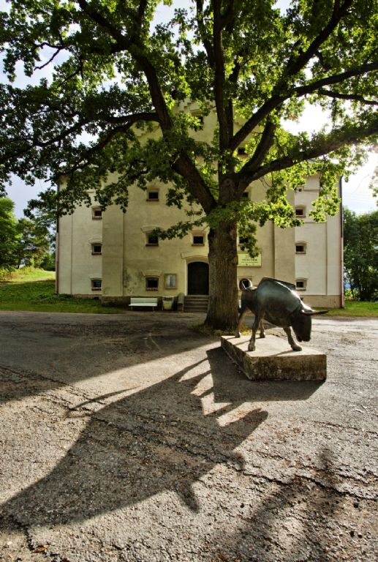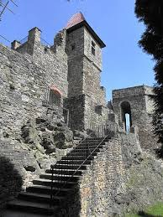
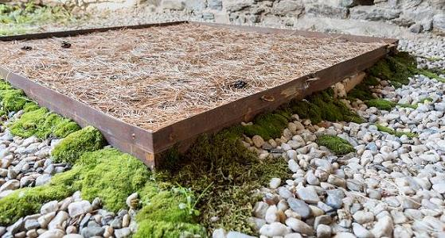

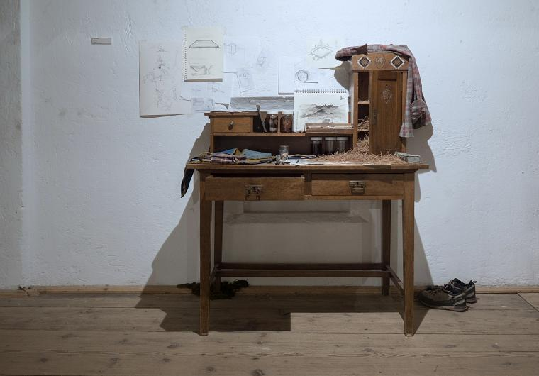
Joshua Graham
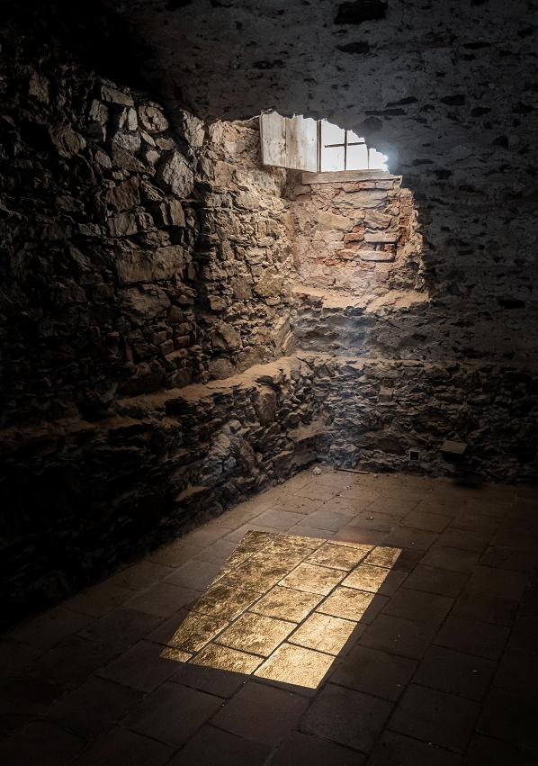
Lenka Konopasek
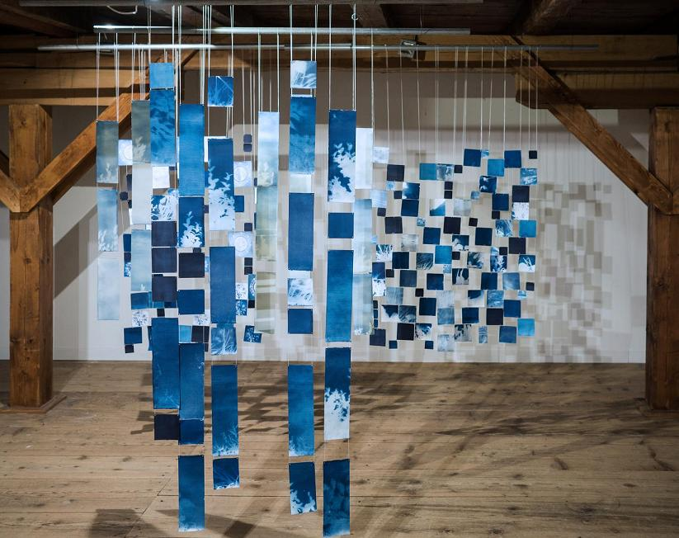
Etsuko Kato
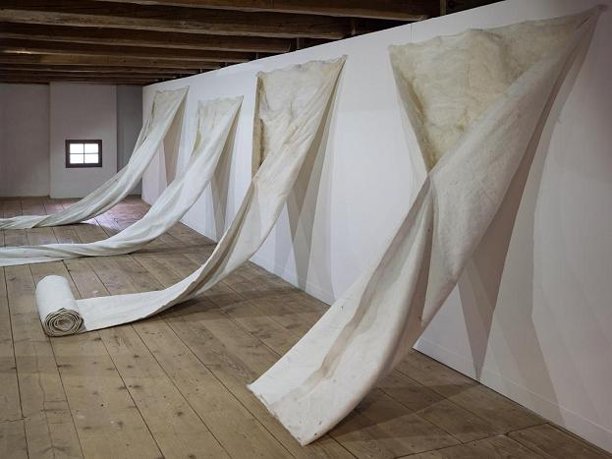
Lenka Konopasek

